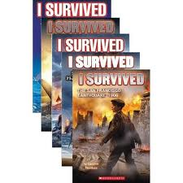

**Who**: Attention all 4th and 5th graders

**What**: Lauren Tarshis writing activity

Lauren Tarshis, author of the wildly popular “I Survived” series, will be visiting our school on March 20, 2013. She has written 7 books in this series, each a historical, thrilling story told through the eyes of a boy who lived to tell the tale. Have you ever survived an event such as this? With 250 words or less, write about this event.

Or, in your opinion, what other historical event would be a good idea for an “I Survived” story and why? Again, please write about it in 250 words or less.

**When**: Your entry must be submitted by Tuesday, March 12, 2013.

**Where**: Please submit your entry to Mr. Mullarkey in the library.

**Why**: To celebrate the arrival of Lauren Tarshis and earn the chance to share dessert with her. All students who complete the activity will be entered into a drawing, and several students will be selected randomly to have dessert with Ms. Tarshis.

Please be sure to include your name and grade!